Photo Report ISWA AI Netherlands Full Version

Campaign Control Arms

Benefitconcert Right Moves 06

Tour of Lectures by Richelieu Allison – region manager West African Youth Network

Right Moves 06 19th April 2006 – Melkweg Amsterdam

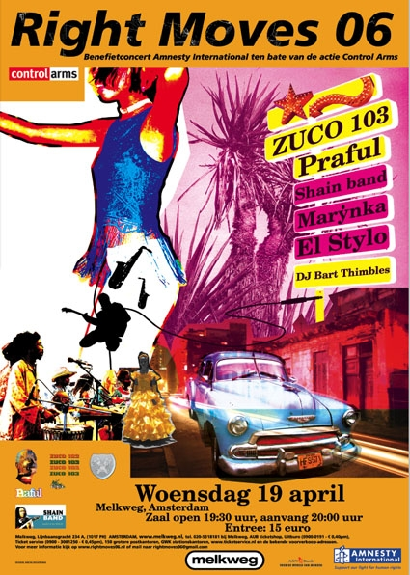
The studentgroups of Amnesty International Netherlands from Amsterdam, organised Right Moves 06. A concert for the benefit of the Campaign Control Arms.

Severel artists performed this night at the Melkweg Amsterdam.The studentgroups have put a lot of time and effort trying to reach artists and promoting the concert. They even made their own promo T-shirts!

Their hard work turned out to be a great succes for there was a large turnout and the audience enjoyed the bands as well as the bands enjoyed the audience.

This night there were also pictures taken for the Million Faces Petition.

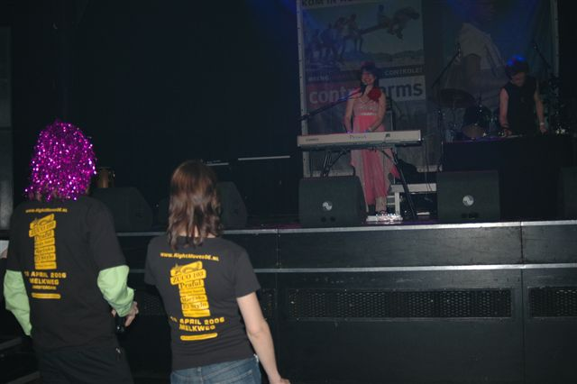
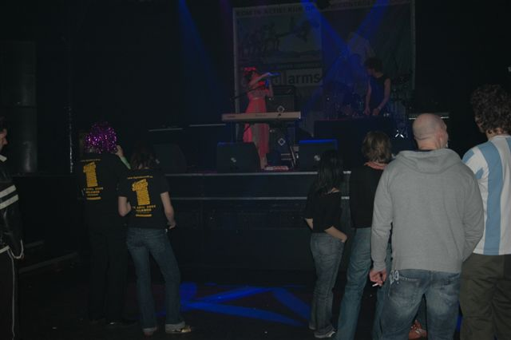
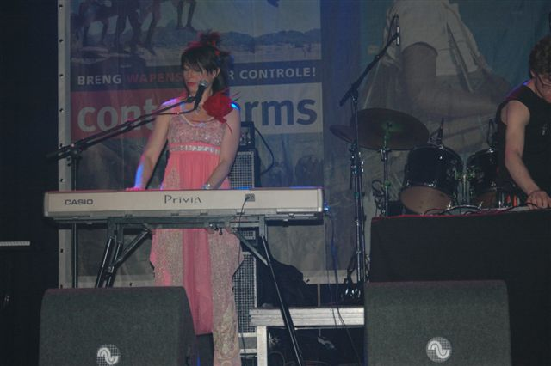

The opening act was the russian singer/songwriter MarỶnka. MarỶnka experiments with a comination of stiles by using a combination of instruments and languages ( Russian, English and French. MarỶnka tries to connect East & West by using classical and pop instruments.

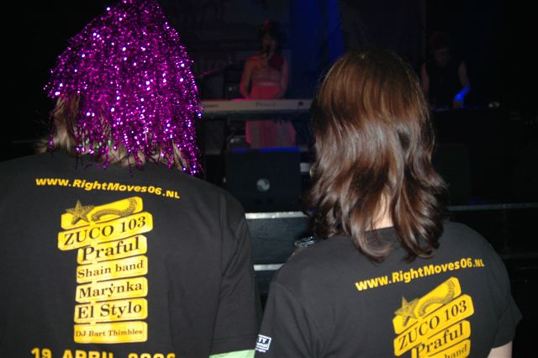
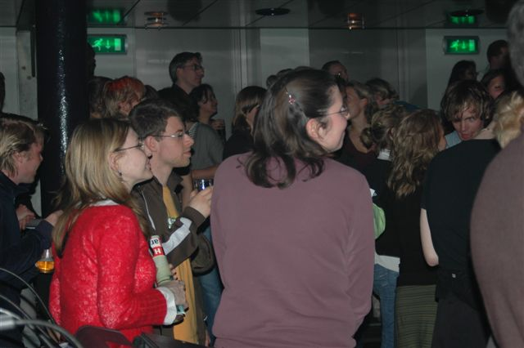
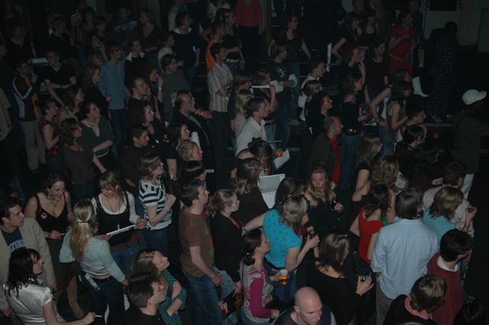
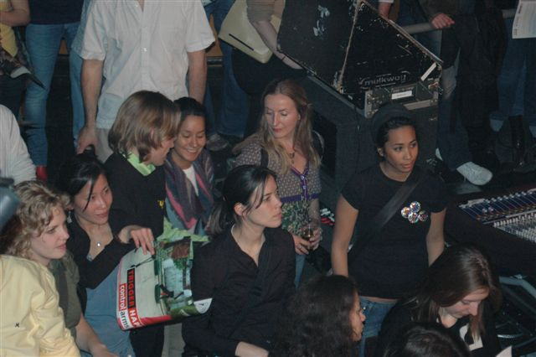

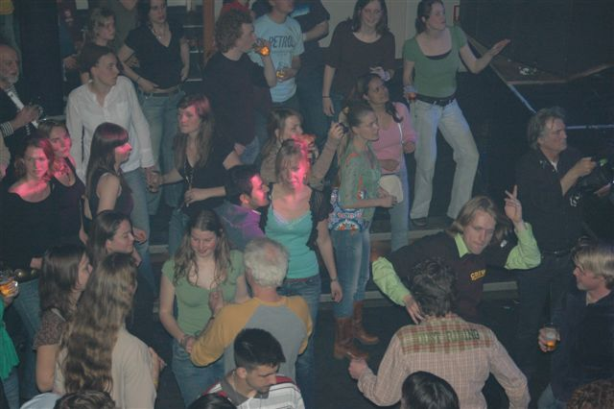
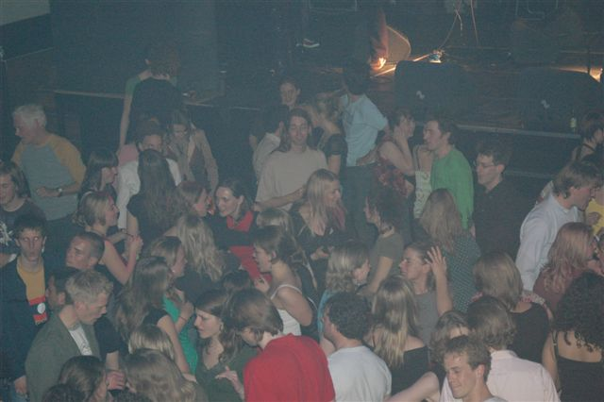
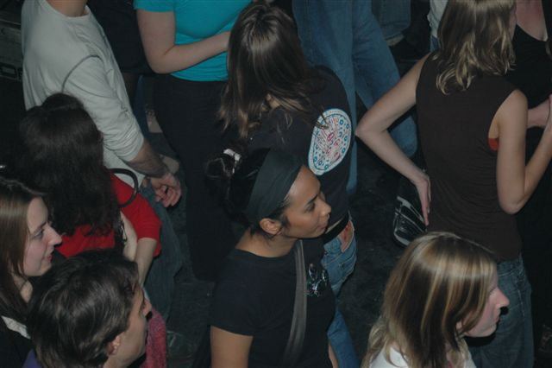

In a very short time the Melkweg was filled with people!The Shain Band from Sierra Leone turned the Melkweg up side down with their wonderfull music. The danser in red added some more spirit by her fabulous dancings. A good mix of fine reggae en funky soul grooves.

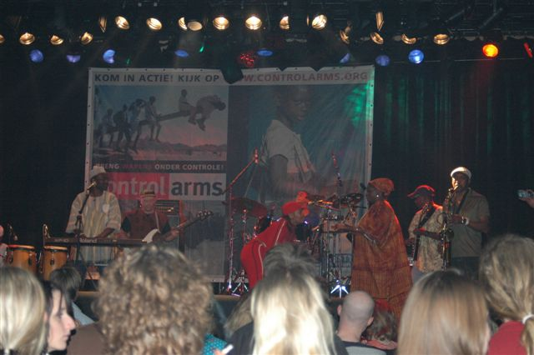
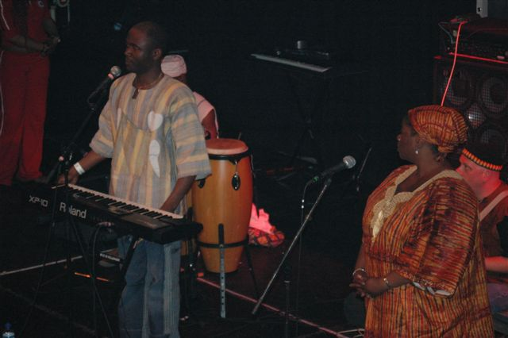
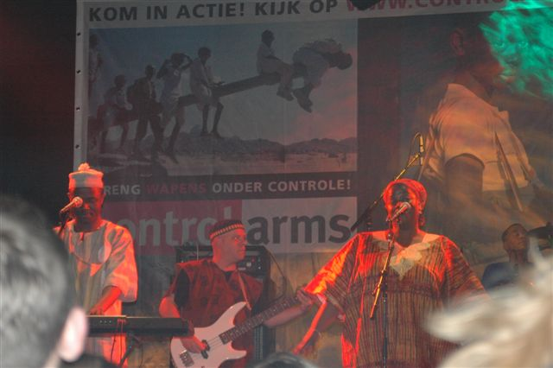

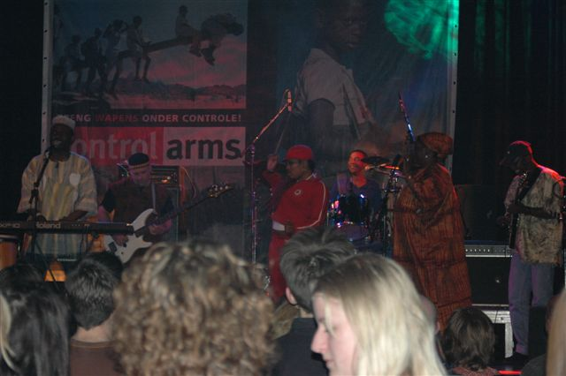
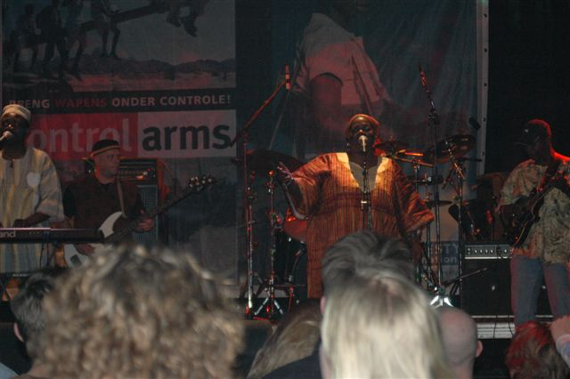
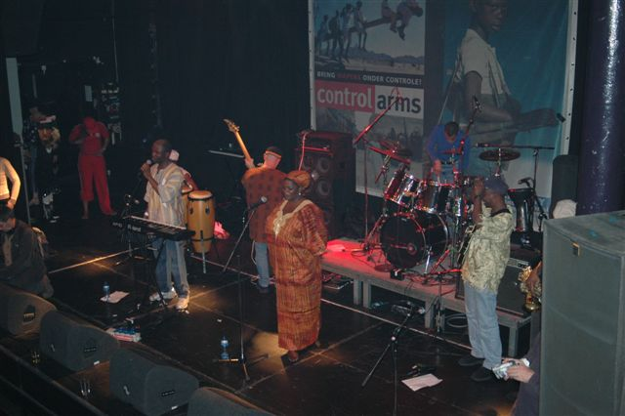

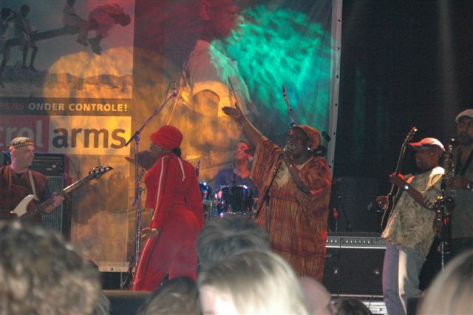
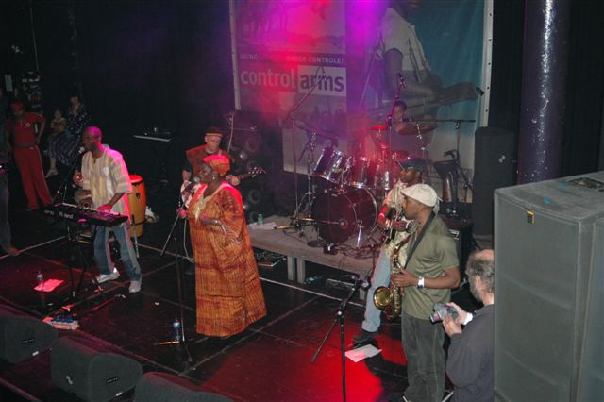
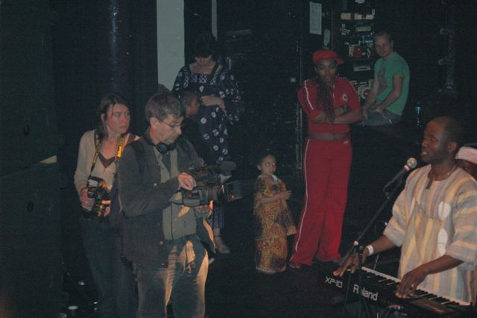

Two short movies were shown about the trade of arms. In between one of the songs of the Shain Band, the leadsinger called for a major groupphoto for the Million Faces Petition. The Melkweg took a moment of time to stand still by the casualties of arms and took action and joined the Million Faces Petition.

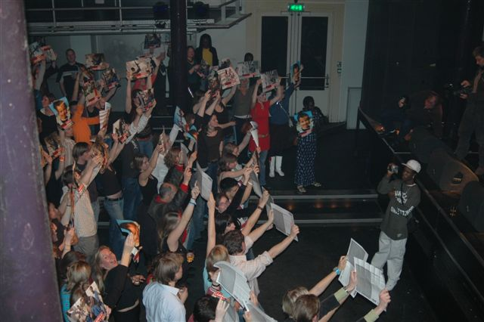
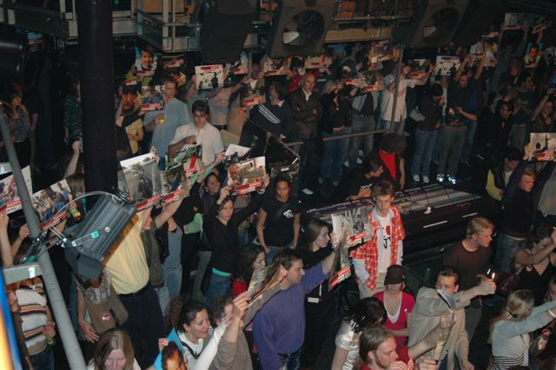

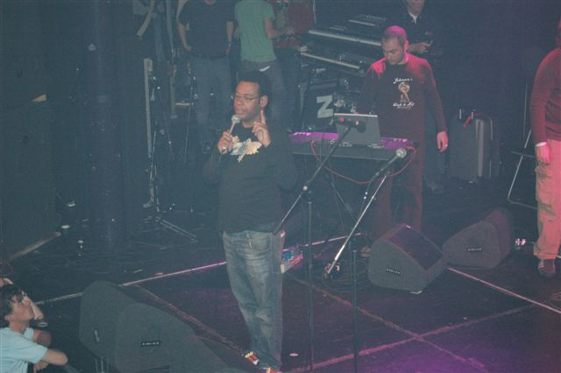
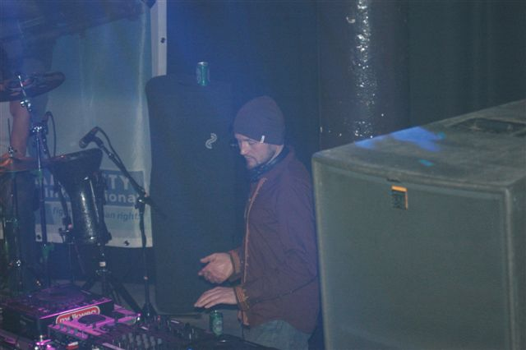
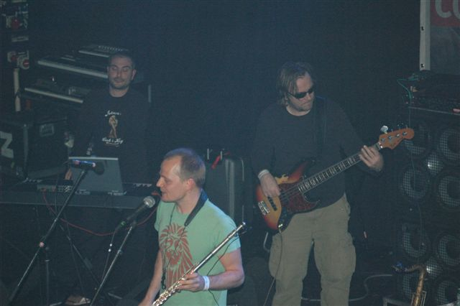
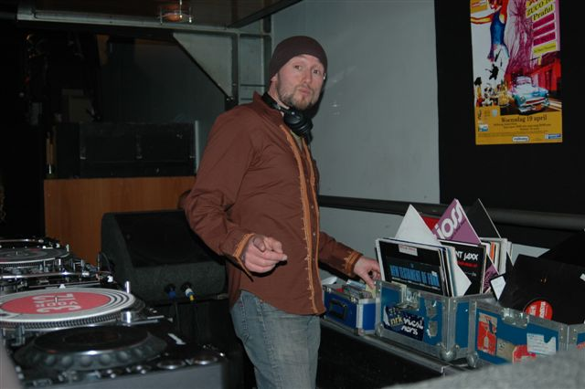

Saxophone- Flute- and Bansuri player Praful, performed a mix of Jazz, Dance and Tripplepop. Inspired by West african, Brazillian and Indian music. ZUCO 103 closed the evening with an amazing show!

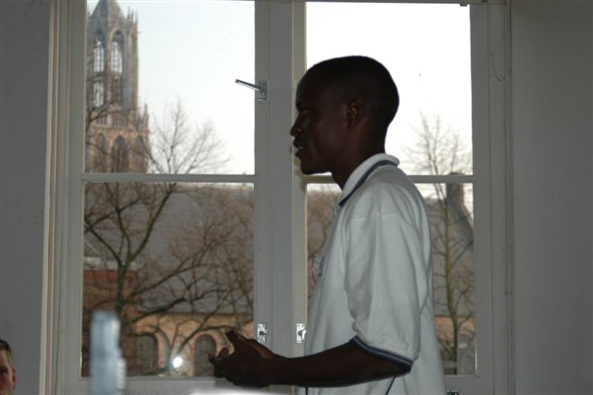
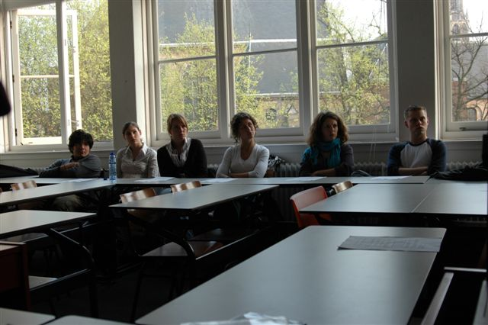
Lecture 24th April 2006 – Utrecht
The Youth & Students department Netherlands linked Ex-Child Girl Soldiers to the Campaign Control Arms and Stop Violence Against Women.

Six Amnesty International Netherlands Student Groups organised a lecture with speaker Richelieu Allison.

Richelieu Allison established the West African Youth Network( WAYN). He’s now a region manager of WAYN and encourages African youngsters to help with projects that are beneficial for peace and human rights, conlict management and AIDS prevention.

The West African Youth Network (WAYN) is a regional youth empowerment organization established by four young people from West Africa in March 2001.

WAYN seeks to serve as an advocacy mechanism and Public Policy Voice for the cause of young people in West Africa as well as to empower young people to get involved in practical projects geared towards peace building, human rights, conflict resolution, good governance and HIV/AIDS Prevention.

Caravan 2006
Along with the MRU Youth Parliament WAYN initiated the The Mano River Union Youth Caravan 2006 It seek to build on the success of the first MRU Youth Peace Caravan that was held in November 2004.

The 2006 caravan will focus on raising awareness on Human Rights in selected towns and cities in Guinea, Sierra and Liberia. The major focus of the campaign will be on mobilising communities in fighting violence against women and children. In Liberia, a country that recently completed the disarming and demobilization of thousand of child soldiers, the campaign will also focus on the issue of sensitising communities on the need to reintegrate ex-child soldiers. Emphaisis will be laid on the need to fully reintergrate these unfortune kids back into their communities.

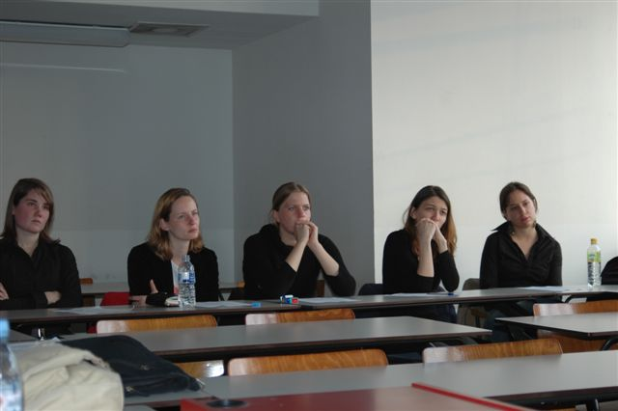

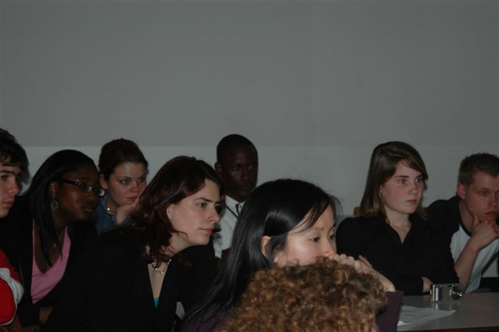
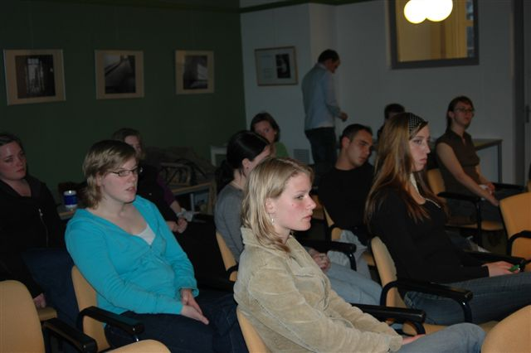
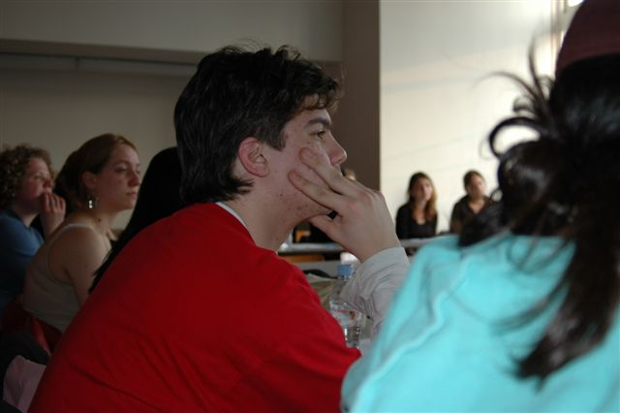
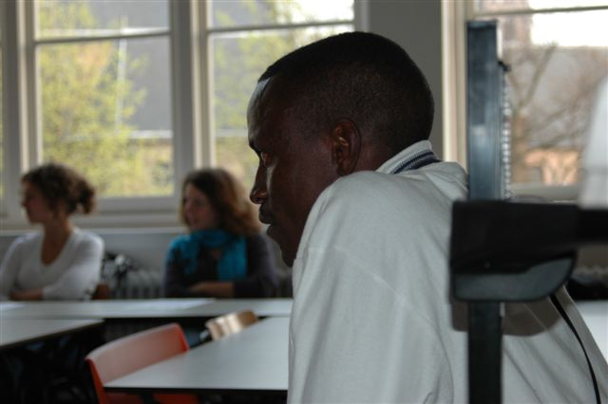
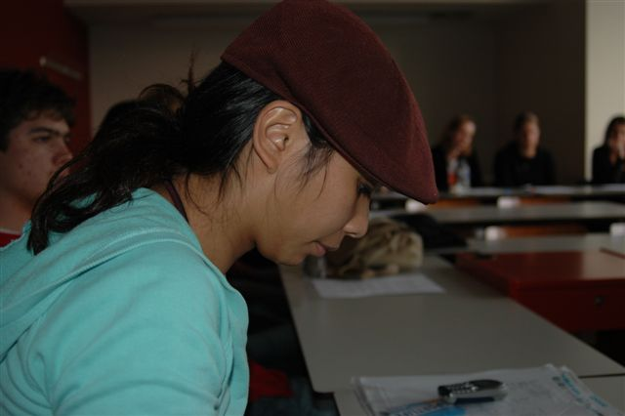
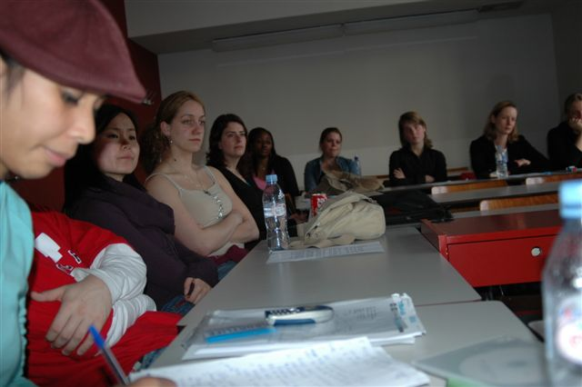
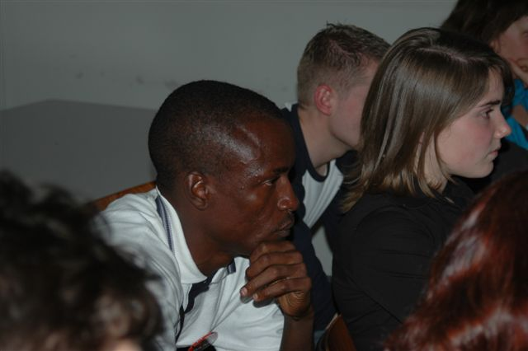
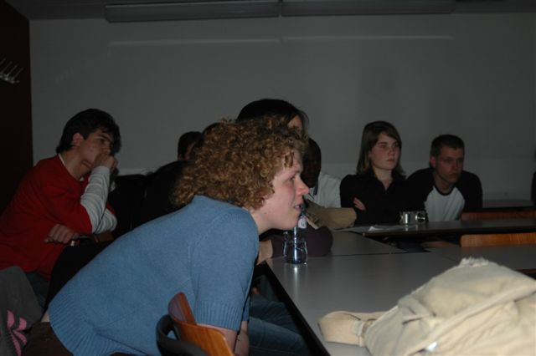

Lecture 26th April 2006 - Amsterdam

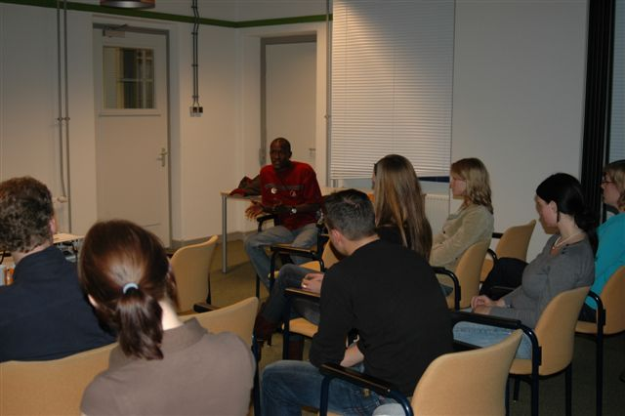
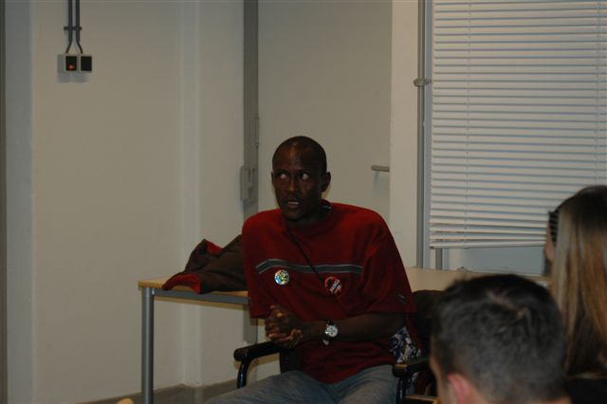
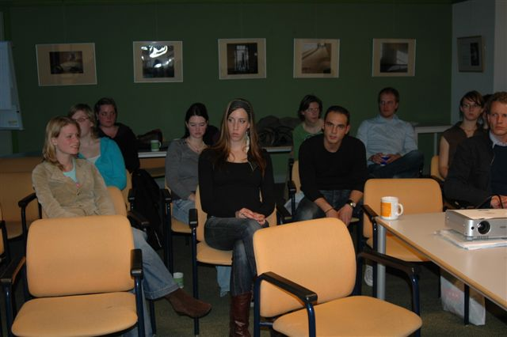

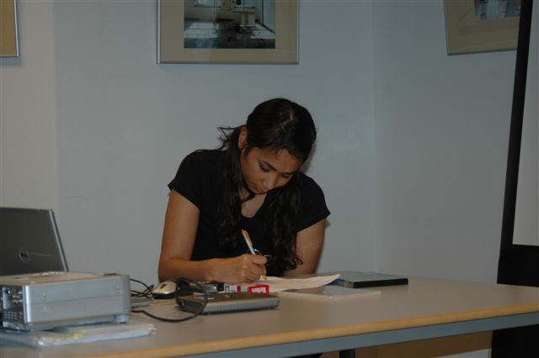
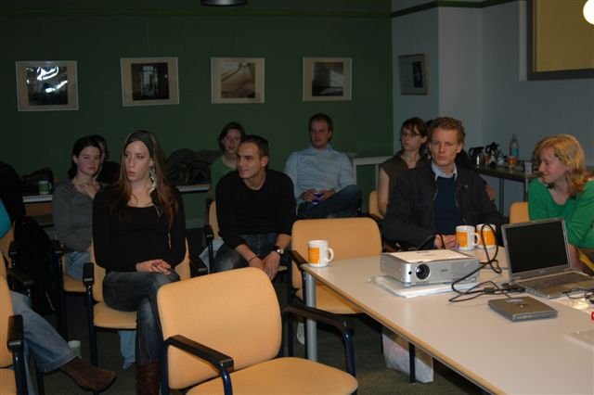
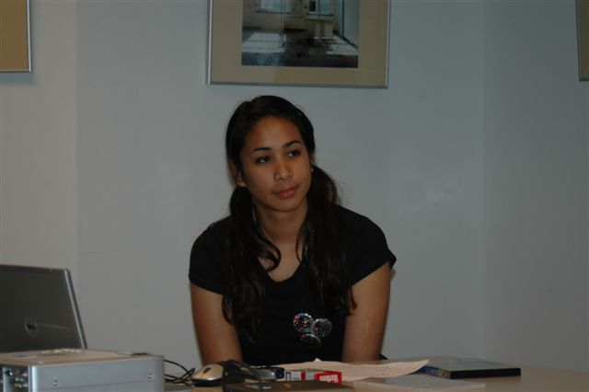

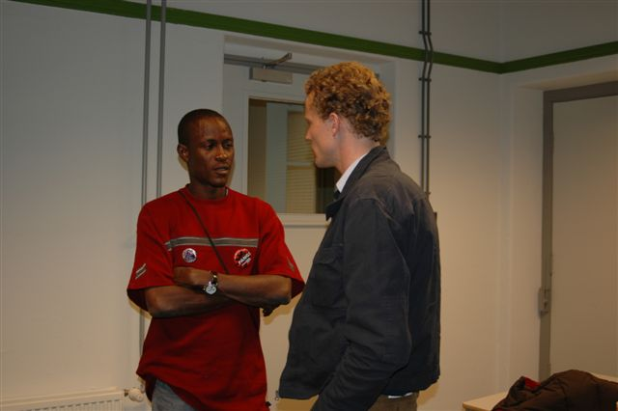
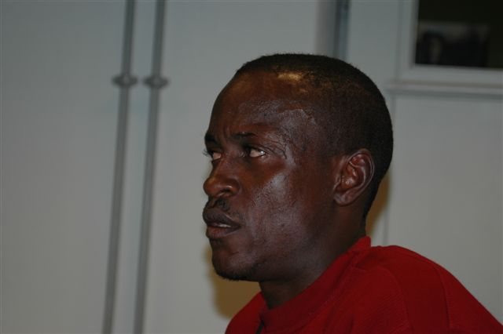
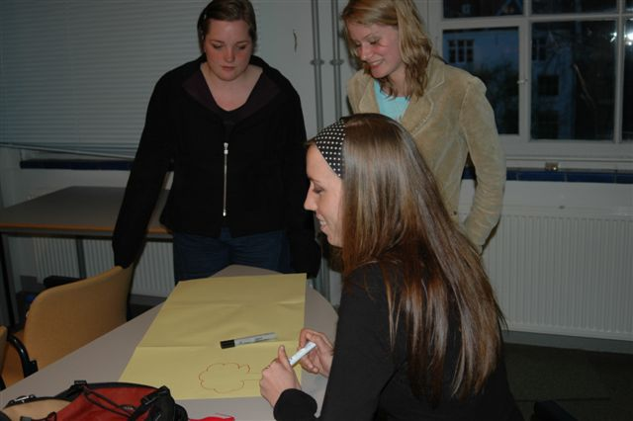

The students wrote short messages to ex-child soldiers to show their support.

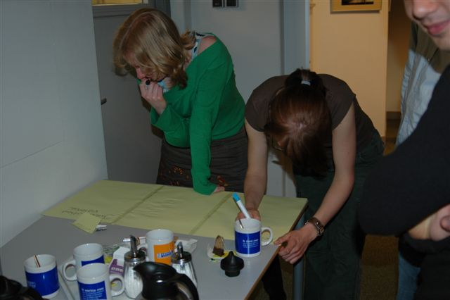
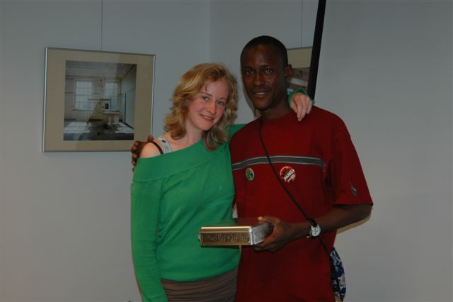
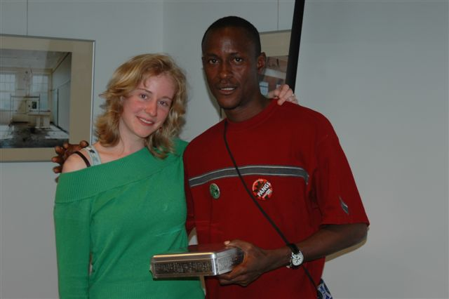

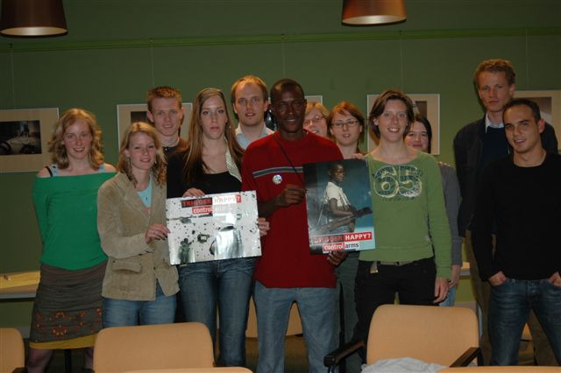
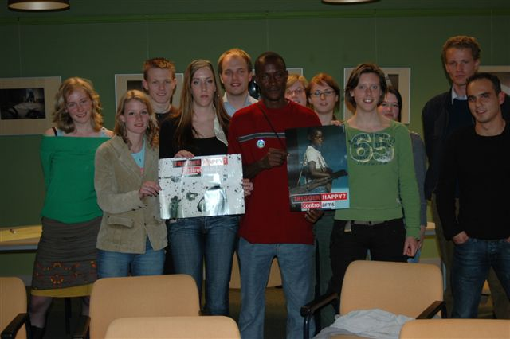

Again there were pictures taken for the Million Faces Petition

Africaday 22th April – Den Haag

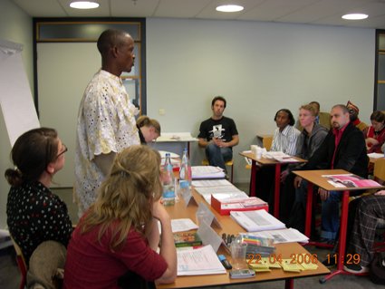
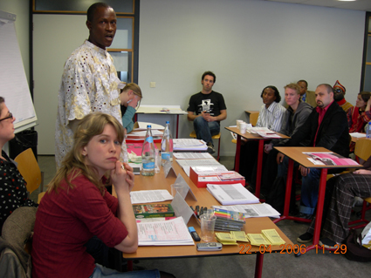
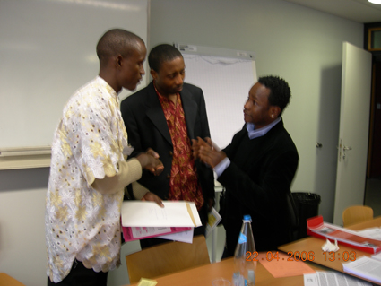

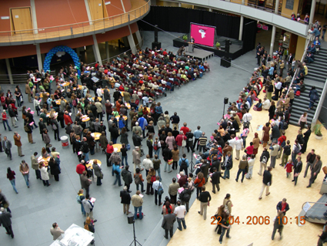
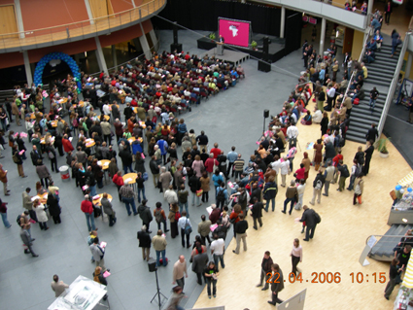
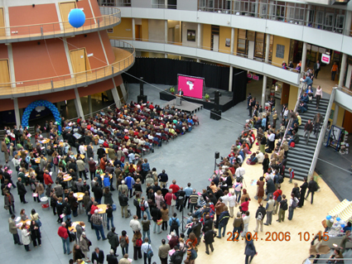

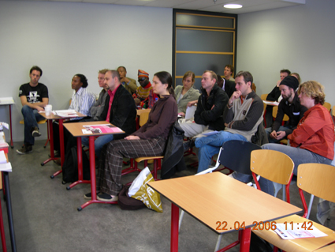
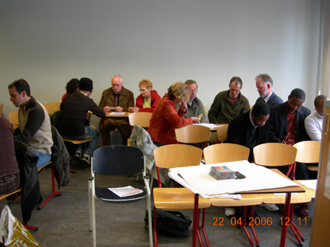

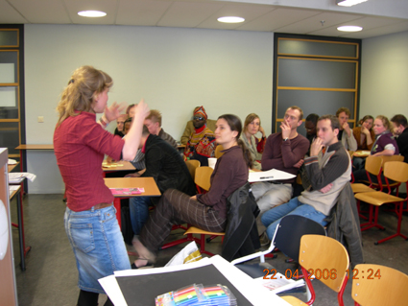

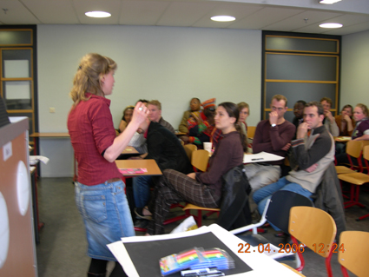

Lecture 25th April 2006 – Leiden
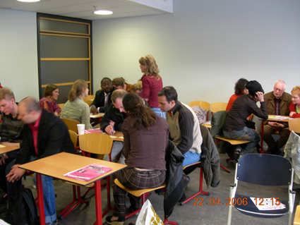

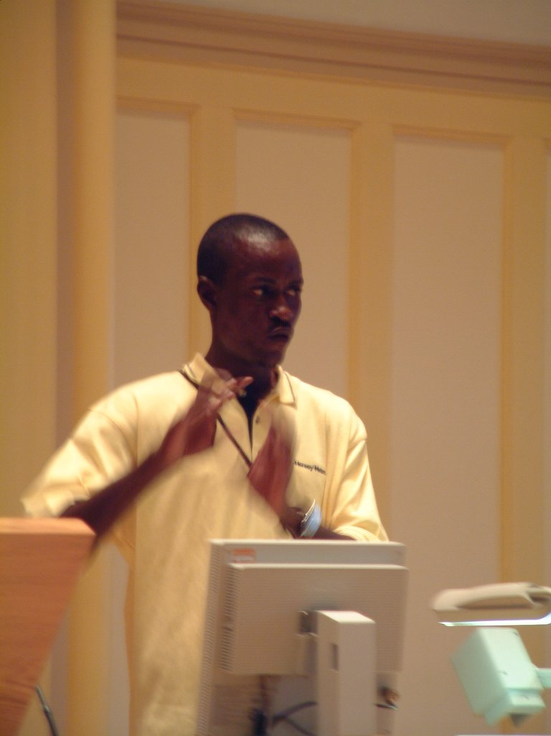
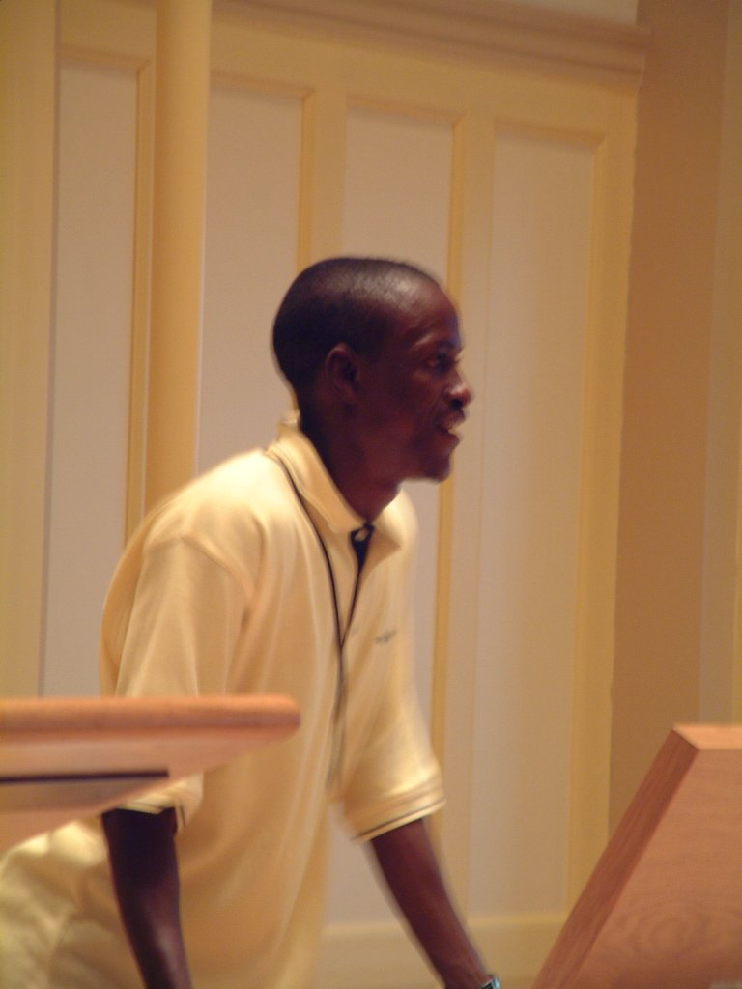

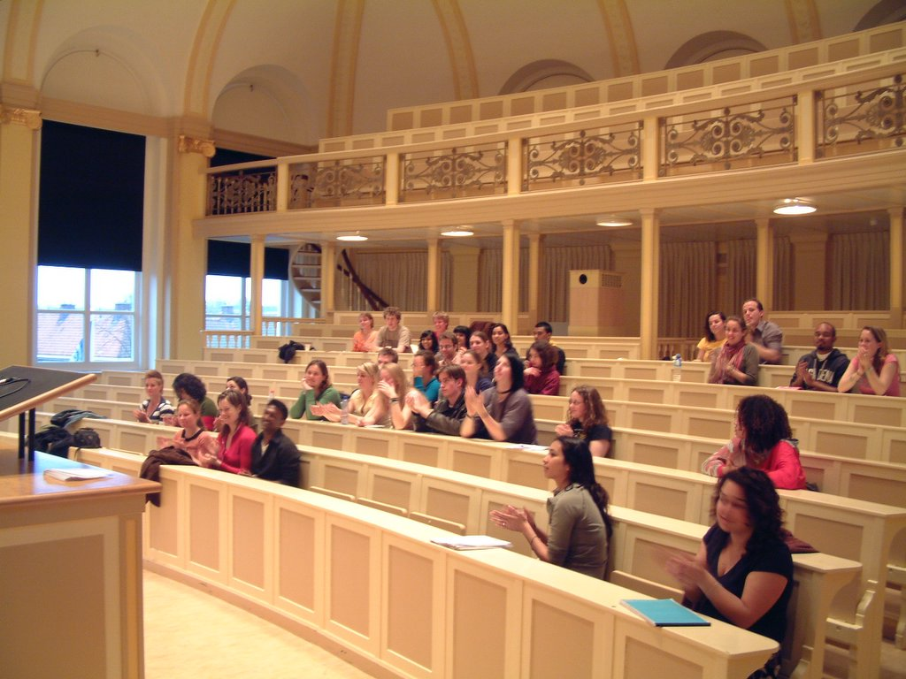

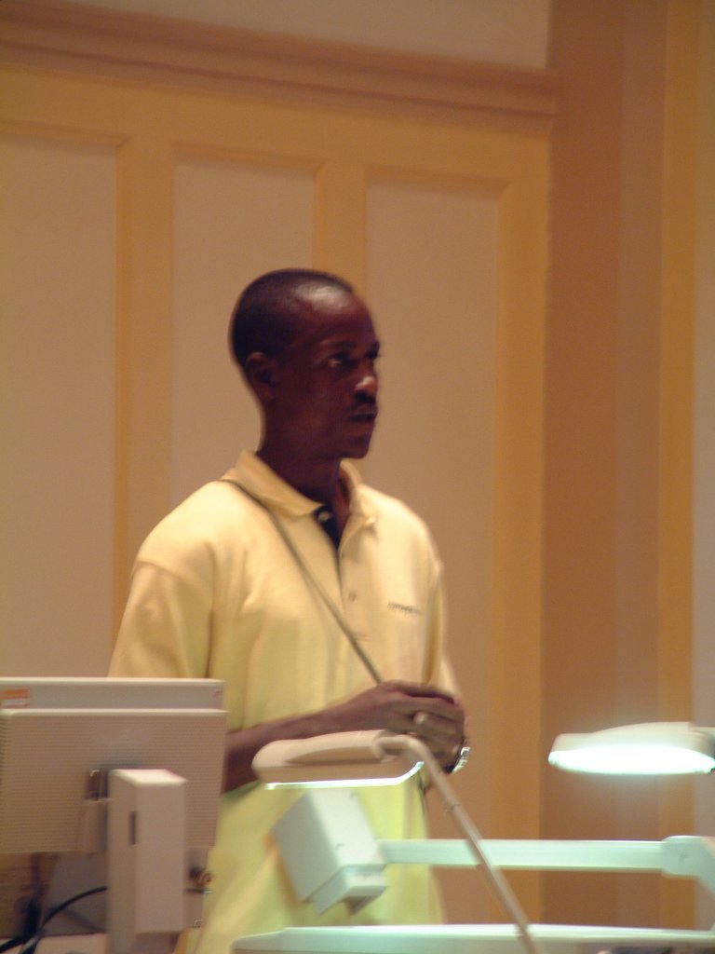

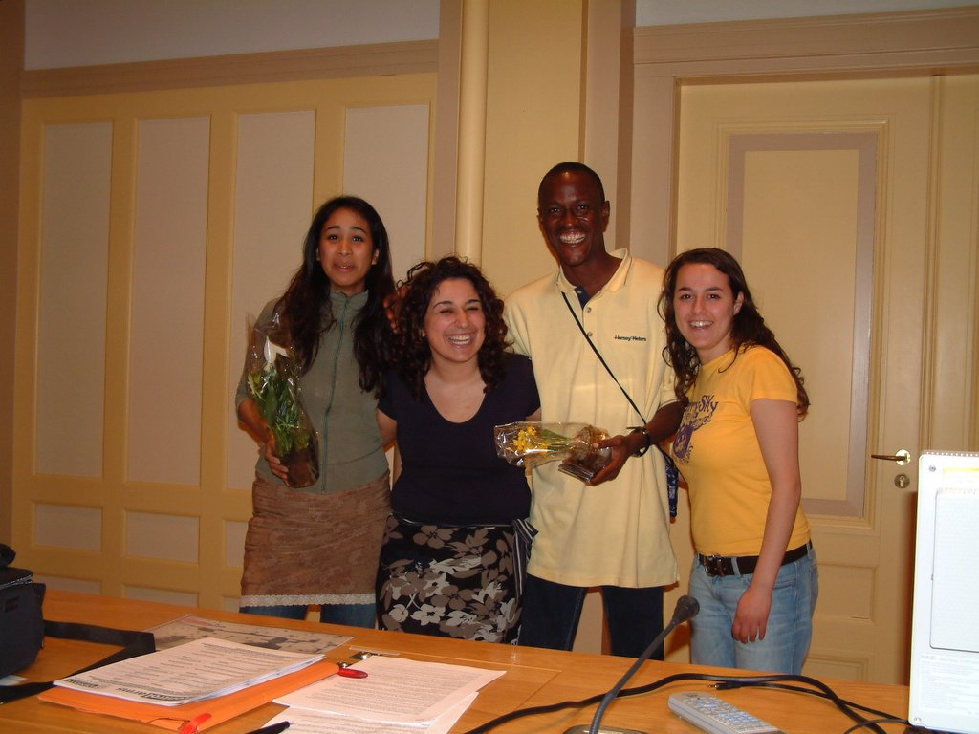
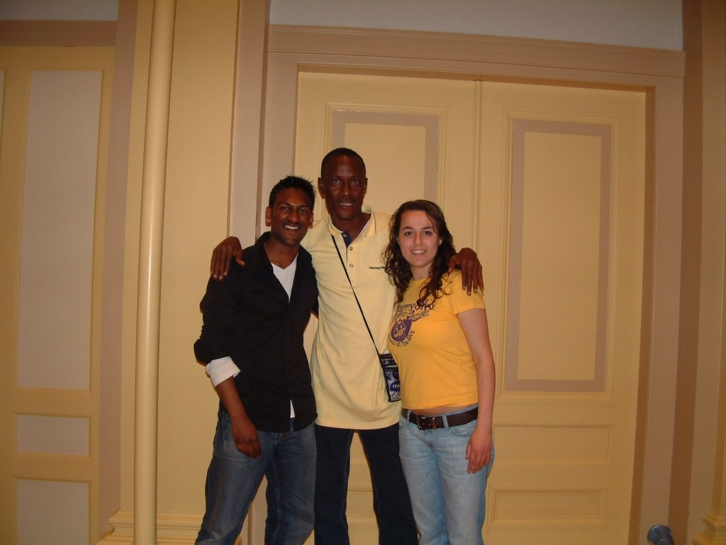

Lecture 27th April - Tilburg

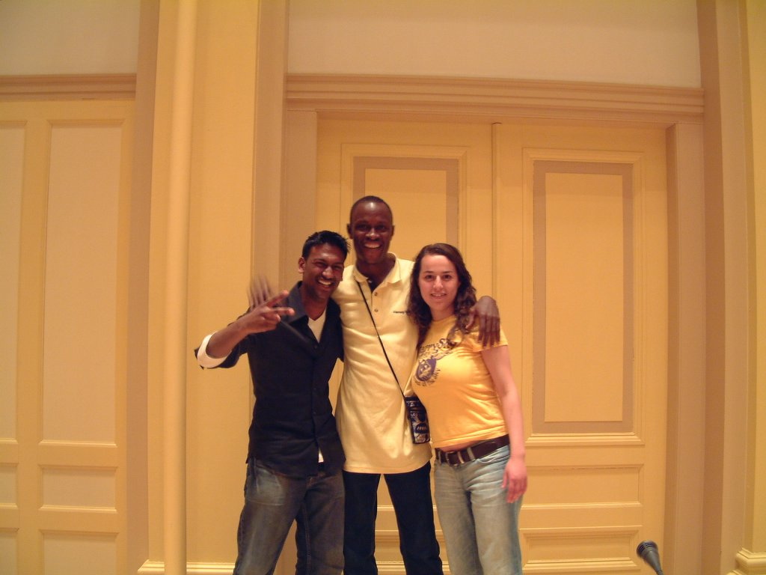

Lecture Tilburg 27th April 2006



